Disabled Adult Residential Enterprises 1616 E. 55th St. Chicago, IL 60615
(773) 667-7313

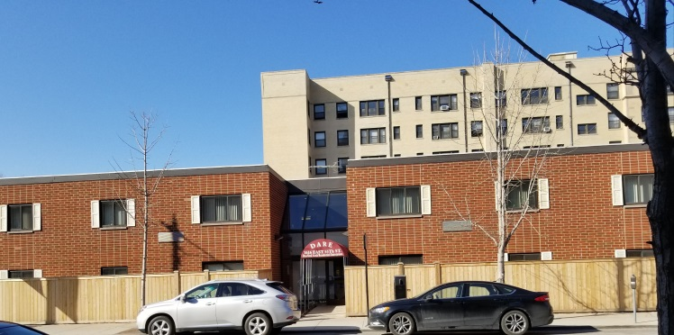

  - Are you looking for housing?
  - D.A.R.E. IS OPENING THE WAITLIST!!
  - Independent living for adults with disabilities.

April 17-21, 2023
Applications taken from 1:00pm-4:00pm Mon-Fri
The waitlist will close promptly at 4:00pm on Friday, April 21, 2023

Disabled Adult Residential Enterprises
1616 E. 55th St.
Chicago IL 60615
773-667-7313

Located in the Hyde Park Neighborhood on the South Side of Chicago. Close to public transportation, great food, and shopping. We offer accessible units, an onsite laundry facility, and plenty of fun activities. Income restrictions apply.

